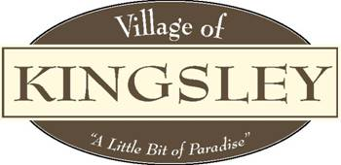

Planning Commission
Minutes
207 S. Brownson Ave
Kingsley, MI 49649
July 26th, 2023

Motion by Tara Jeffreys, supported by Chris Bott to call meeting to order at 6:00pm. CARRIED by all.

Pledge of Allegiance

Roll Call: Bott X , Forro X , Jeffreys X , Nickerson X , Smith Ab , Weger Ab Willman X .

Also Attending: Manager Aldrich Ab ,

Public in Attendance: No public in attendance

- Motion to approve May 17th, 2023, Public Hearing, minutes.
Motion by Tara Jeffreys, supported by Dawn Willman, to approve May 17th, 2023, minutes as presented. CARRIED by all.
- Additions or Deletions to July 26th, 2023, Agenda. None
- Motion to approve the July 26th, 2023, Agenda.
Motion by Christina Forro, supported by Dawn Willman to approve the July 26th agenda as presented. CARRIED by all.
- Conflict of Interest. Note noted.
- Public Comment – General. No public in attendance
- Public Comment – Agenda items. No public in attendance
- Presentations: None

FYI: None

New Business: None

Old Business:
- Master Plan. Will be starting in November.
- Capital Improvement Plan. Nothing to report.

Committee Reports:
- Village Manager – Kaitlyn Aldrich. Absent
2. Village Council – Eric Weger. Report given by Chris Bott in Eric Weger’s absence.
3. Zoning Administrator’s May Report.
4. RRC Ad Hoc Committee Update – Chris Bott. Nothing to report.

Adjournment: Motion by Dawn Willman, supported by Christina Forro to adjourn meeting at 6:15pm. CARRIED.

