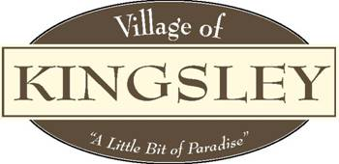

Planning Commission
Agenda
207 S. Brownson Ave
Kingsley, MI 49649
July 26th, 2023

Meeting Called to Order

Pledge of Allegiance

Roll Call: Bott , Forro , Jeffreys , Nickerson , Smith , Weger Willman .

Also Attending: Manager Aldrich ,

Public in Attendance:

- Motion to approve May 17th, 2023 Public Hearing, minutes.
- Additions or Deletions to July 26th, 2023 Agenda.
- Motion to approve the July 26th, 2023 Agenda
- Conflict of Interest.
- Public Comment – General.
- Public Comment – Agenda items
- Presentations:

FYI:

New Business:

Old Business:
- Master Plan
- Capital Improvement Plan

Committee Reports:
- Village Manager – Kaitlyn Aldrich
2. Village Council – Eric Weger
3. Zoning Administrator’s May Report
4. RRC Ad Hoc Committee Update – Chris Bott

Adjournment: Motion to adjourn meeting

