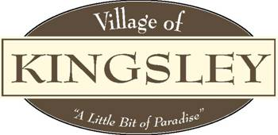

Planning Commission
Agenda
207 S. Brownson Ave
Kingsley, MI 49649
January 25th, 2023

Meeting Called to Order

Pledge of Allegiance

Roll Call: Bott , Forro , Jeffreys , Nickerson , Smith , Weger Ab Willman .

Also Attending: Manager Aldrich Ab , ZA Williams Ab .

Public in Attendance:

- Motion to approve November 16th, 2022 minutes.
- Additions or Deletions to January 25th, 2023 Agenda.
- Motion to approve the January 25th, 2023 Agenda
- Conflict of Interest.
- Public Comment – General.
- Public Comment – Agenda items
- Presentations:
- Dane Moeggenberg and Bruce Grossman re: Taproom at 309 W. Main St.

FYI: Planning Commission By-Laws (informational only)

New Business:

- Stoney Acre Barns Special Use Permit
- Election of officers 2023-2024
1. Nomination and Election of Officers
a. Chair
b. Vice Chair
c. Secretary

Motion by ______, supported by ______, to appoint
a. ___________ as Planning Commission Chair
b. ___________ as Planning Commission Vice Chair
c. ___________ as Planning Commission Secretary

Roll Call Vote:
Ayes:
Nays:
Abstain:
Absent:

- Approval of 2023-2024 Meeting Schedule

Old Business:
- Short Term Rental – informational newsletter update given by Mika, Meyer (Village Attorneys).
- Master Plan
- ZA Roger Williams recommendations on the Networks Northwest Master Plan services
- Capital Improvement Plan

Committee Reports:
- Village Manager – Kaitlyn Aldrich
2. Village Council – Eric Weger
3. Village Zoning Administrator – Roger Williams
a. . Zoning Reports –November & December 2022 report
4. RRC Ad Hoc Committee Update – Chris Bott

Adjournment: Motion to adjourn meeting

